**Lab 14 - Performing advanced data analytics on business database and answering business questions using Azure OpenAI Service**

**Introduction**

This lab delves into the integration of Azure OpenAI capabilities to answer business questions through advanced data analytics performed on a business database. Leveraging the power of Open AI, such as ChatGPT/GPT-4, you'll learn to construct complex queries and glean insights from the data. The lab showcases the application's versatility by addressing questions of varying complexity, such as revenue trends and forecasting.

Examples of questions are:

* **Simple**: Show me daily revenue trends in 2016 per region
* **More difficult**: Is that true that top 20% customers generate 80% revenue in 2016?
* **Advanced**: Forecast monthly revenue for next 12 months starting from June-2018

This integration supports both Python's built-in SQLITE and Microsoft SQL Server, providing a comprehensive analytical toolset for businesses.

**Objective**

* To deploy gpt-35-turbo model in Azure OpenAI Studio in order to facilitate the subsequent business question analysis.
* To efficiently create an Azure SQL Database with relevant configurations in preparation for data analysis tasks.
* To configure the hosted demo application and use SQL Query Writing Assistant and Data Analysis Assistant of the demo app for SQL query translation and advanced data analysis.
* To delete the gpt-35-turbo model, SQL database, and SQL server.

**Important:** You can proceed with this lab only GPT-4 is available on your Azure OpenAI Service. If it is not approved, you can request access to GPT-4 https://aka.ms/oai/get-gpt4

**Task 1: Create Azure OpenAI resource**

1. In Azure portal, click on **portal menu** represented by three horizontal bars on the top left corner of page, as shown in the below image

1. Navigate and click on **+ Create a resource**.

1. On **Create a resource** page, in the **Search services and marketplace** search bar, type **Azure OpenAI**, then press the **Enter** button.

1. In the **Marketplace** page, navigate to the **Azure OpenAI** tile, click on the V chevron button beside **Create**, then navigate and click on the **Azure OpenAI** as shown in the below image.

1. In the **Create Azure OpenAI** window, under the **Basics** tab, enter the following details and click on the **Next** button.

| **Subscription** | **Select your subscription** |
| --- | --- |
| **Resource group** | Click on **Create new**> enter **AOAI-RGXX** (XX can be a unique number) |
| Region | Select **West US** |
| Name | **azure-openai-testXX** (XX can be a unique number) |
| Pricing tier | Select Standard S0 |

1. A screenshot of a computer

   Description automatically generated
2. A screenshot of a computer

   Description automatically generated
3. In the **Network** tab, leave all the radio buttons in the default state, and click on the **Next** button.

1. In the **Tags** tab, leave all the fields in the default state, and click on the **Next** button.

1. In the **Review + submit** tab, once the Validation is Passed, click on the **Create** button.

1. Wait for the deployment to complete. The deployment will take around 2-3 minutes.

1. On **Microsoft.CognitiveServicesOpenAI** window, after the deployment is completed, click on **Go to resource** button.

**Task 2: Deploy the models in Azure OpenAI**

1. Open your browser, navigate to the address bar, and type or paste the following URL: **https://oai.azure.com/** then press the **Enter** button.

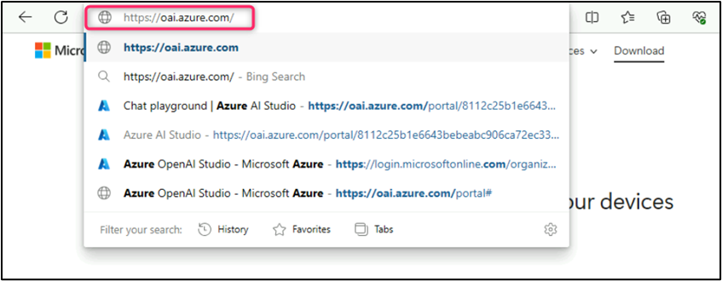

**Note**: If you are directed to the **Azure OpenAI Studio** home page, then skip steps #2 to #4, else continue.

1. In the **Microsoft Azure** window, enter your **Sign-in** credentials, and click on the **Next** button.

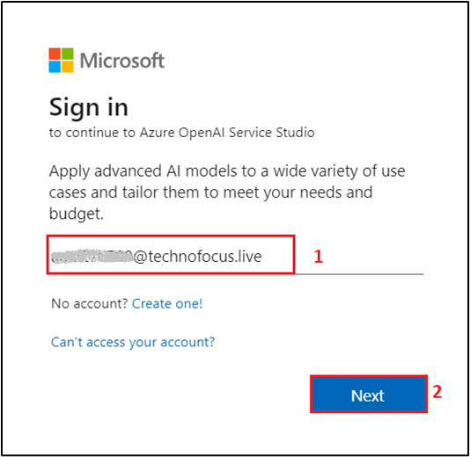

1. Then, enter the password and click on the **Sign in** button**.**

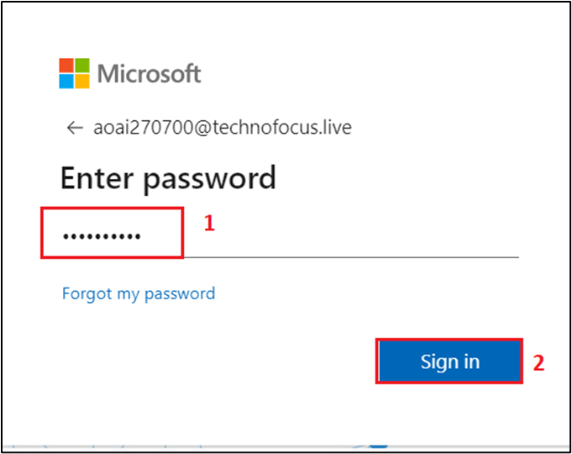

1. In **Stay signed in?** window, click on the **Yes** button.

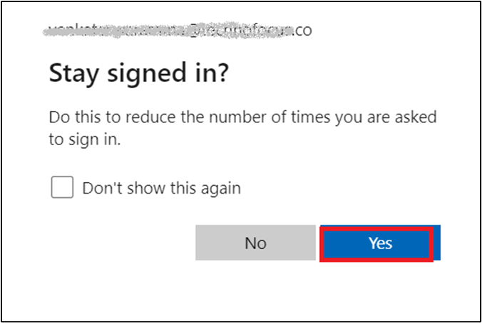

1. On the **Welcome to Azure OpenAI Studio** dialog box, under the **Subscription** field, enter the subscription assigned to you, and in the **Resource** field, select the Resource name that you've created in Lab #1, and then click on the **Use resource** button.

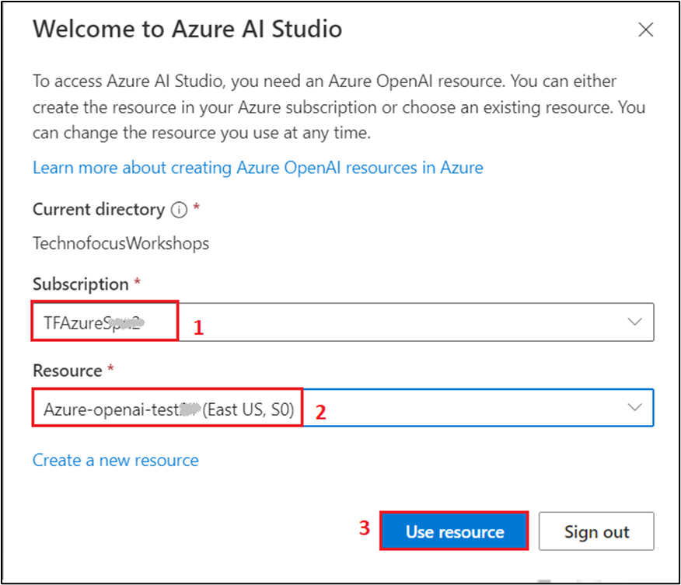

1. Wait for the Azure OpenAI studio to launch.

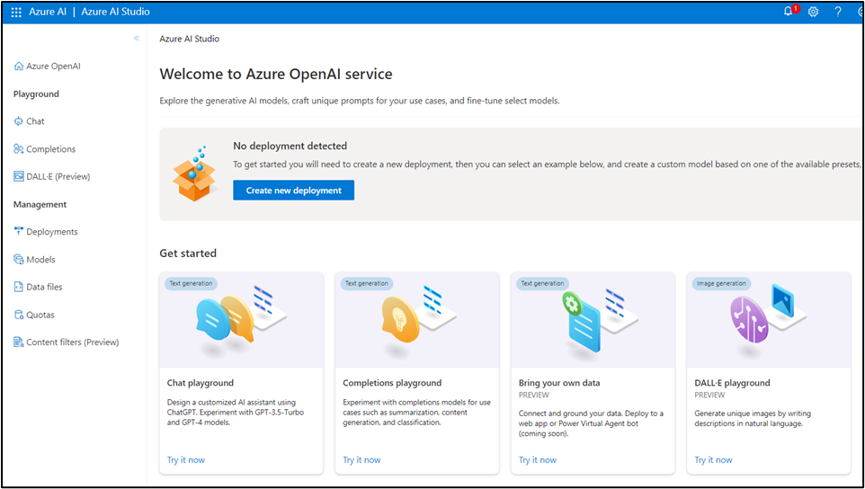

1. On the **Azure OpenAI Studio** homepage, click on **Create new deployment** button.

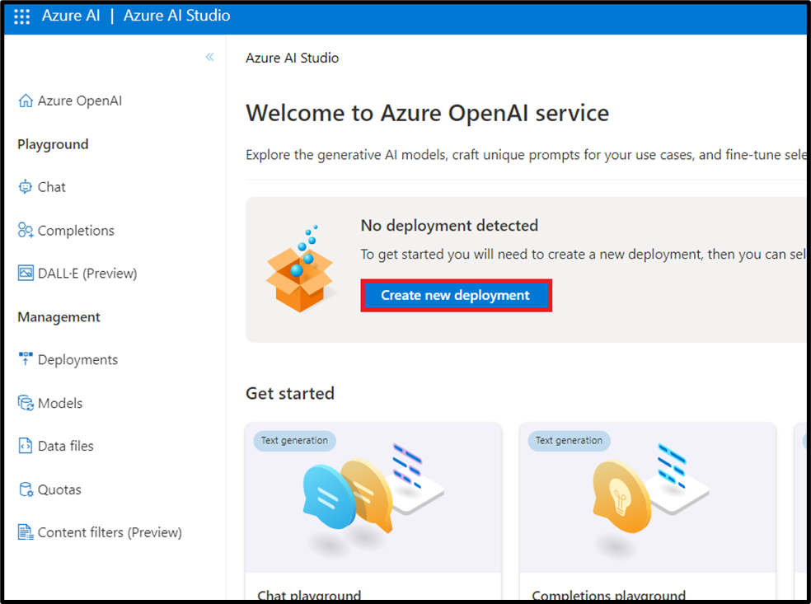

1. In the **Deployments** page, click on +**Create new deployment**.

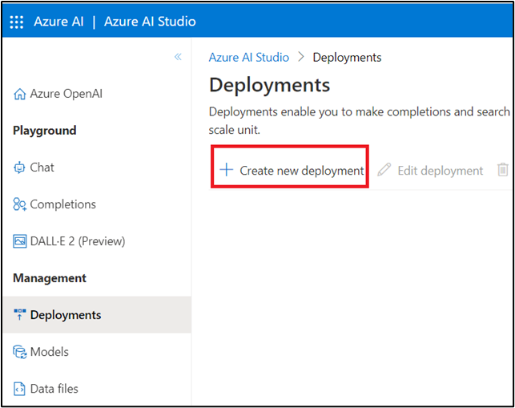

1. In the **Deploy model dialog** box, under the **Model name** field, click on the V chevron button; navigate and select carefully **gpt-35-turbo**.

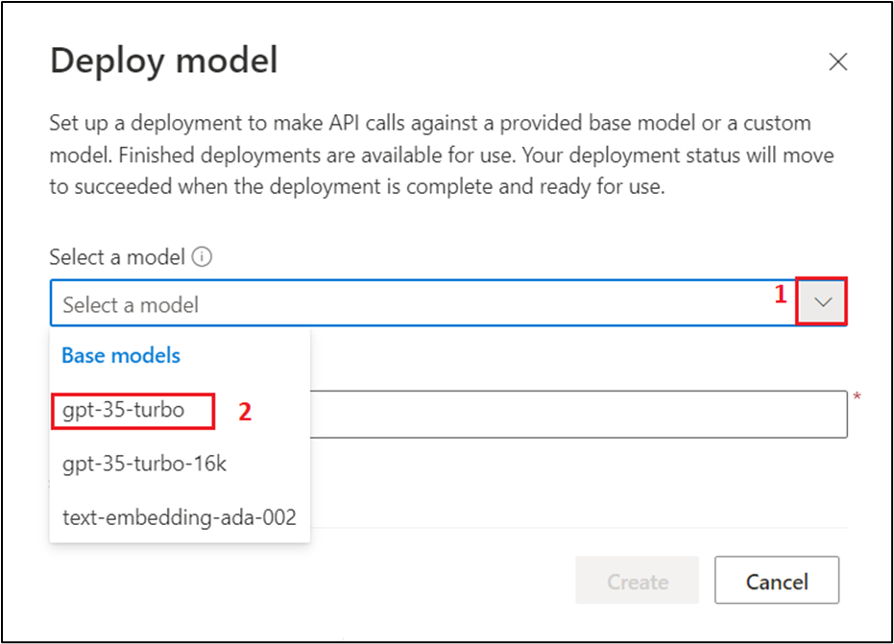

1. Select the **Model version** as **Auto-update to default,** in the **Deployment name field**, enter **gpt-35-turbo**, and click on the **Create** button.

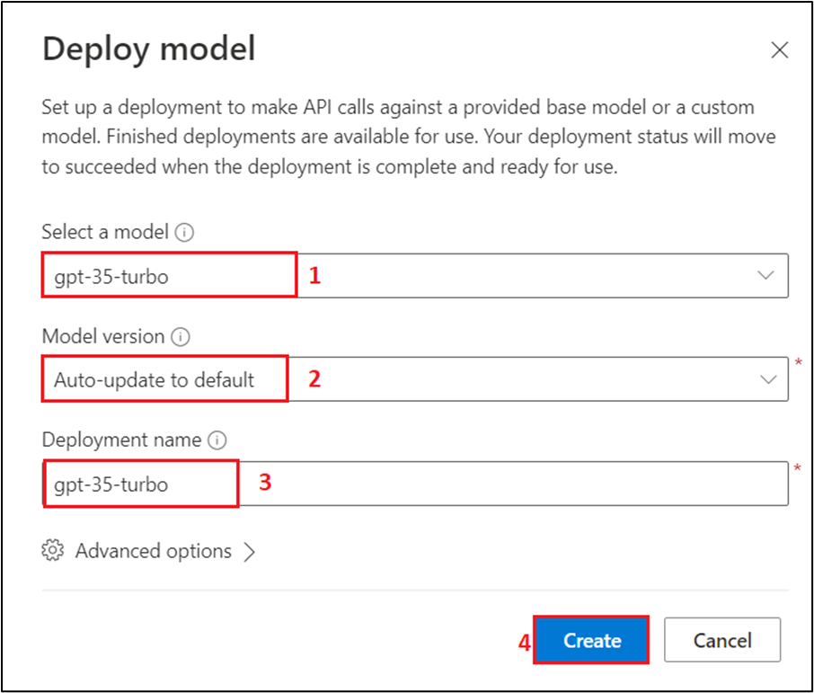

1. You will see a notification -- **Successfully Created deployment** when the deployment is succeeded (You can also view the notification by clicking on the bell icon beside **Azure AI | Azure AI Studio)**.

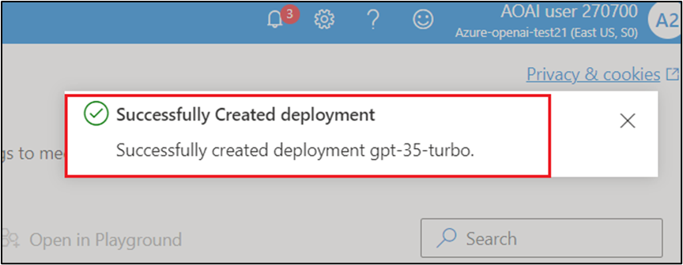

1. In the **Deployments** page, click on **+Create new deployment**.

1. In the **Deploy model dialog** box, under the **Model name** field, click on the V chevron button; navigate and select carefully **gpt-4**.

1. In the **Deployment name field**, enter **gpt-4**, and click on the **Create** button.

1. You will see a notification – **Successfully Created deployment** when the deployment is succeeded (You can also view the notification by clicking on the bell icon beside **Azure AI | Azure AI Studio**).

**Task 3: Create an Azure SQL Database**

1. Open your browser, navigate to the address bar, and type or paste the following URL: **https://portal.azure.com/#create/Microsoft.AzureSQL** then press the **Enter** button.

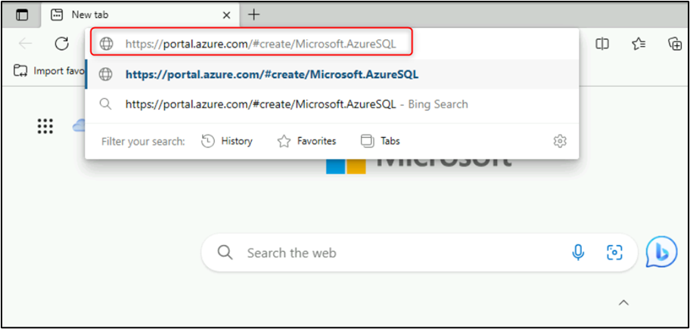

1. Navigate to **SQL databases** section, ensure that **Single database** is selected under **Resource type**, then click on the **Create** button.

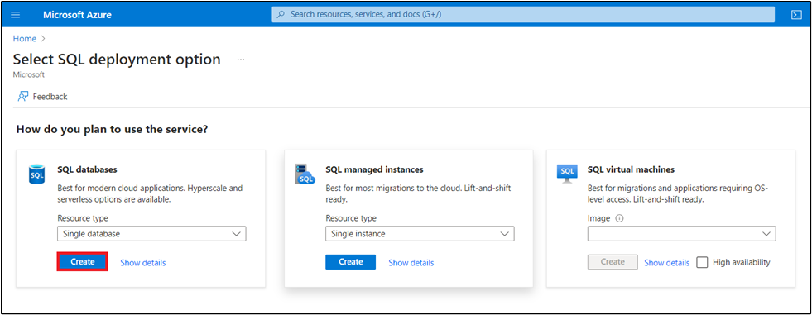

1. On the **Create SQL Database** page provide the following details:

* Subscription -- **Select your Azure OpenAI subscription**
* Resource group -- **Select the Resource group created in Lab #1**
* Database name - **aoaisql**
* Server - **Create new** -- provide the below Server details

i. Server name - **aoaisqlxx** [Substitute **xx** with random number]

ii. Location -- **East US**

iii. Authentication -- **Use both SQL and Microsoft Entra authentication**

iv. Set Azure AD Admin -- Click on **Set admin** and choose the Tenant admin **Select your Azure OpenAI subscription**

v. Server admin login -- **aoaiuser**

vi. Password -- **Password321!**

vii. Confirm password - **Password321!**

viii. Click on **OK**

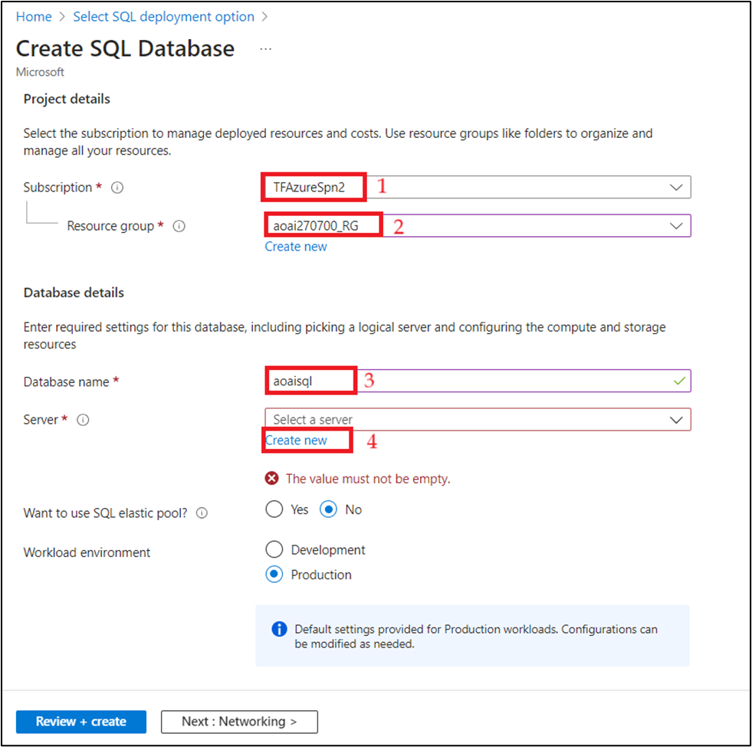

**Note**: Save the **server admin login** and **password** on the notepad to use the information in the upcoming task.

e. Want to use SQL elastic pool? -- **No**

f. Compute + storage -- Click on **Configure database** -- Click on **Service tier** dropdown and Choose **Basic**, then set the Data max size (GB) -- **2**, then click on the **Apply** button.

g. Backup storage redundancy - **Locally-redundant backup storage**

h. Click on **Next: Networking>**

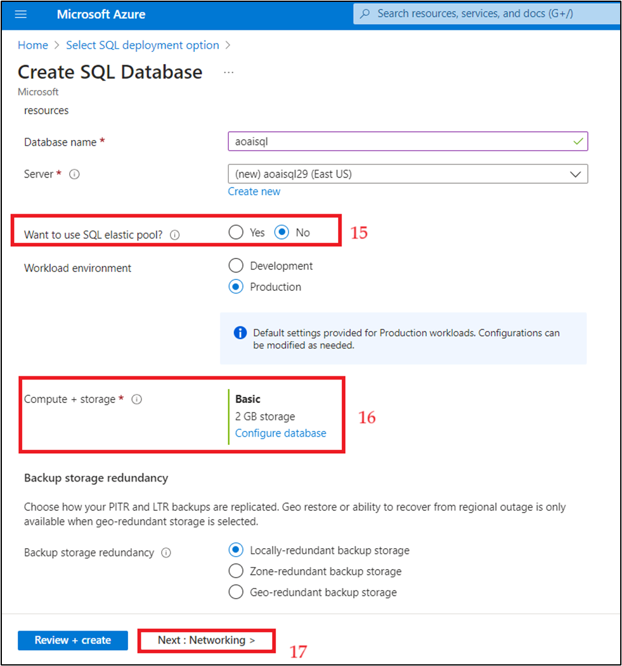

1. On the Networking tab, provide the below details

a. Connectivity method -- **Public endpoint**

b. Firewall rules

* + Allow Azure services and resources to access this server -- **Yes**
  + Add current client IP address - **Yes**

c. Click on **Security**

1. On the **Security** tab, in **Enable Microsoft Defender for SQL** select the check box of **Start free trail** and select **Next: Additional settings**

1. On the **Additional settings** tab, under the **Data source** select the **Sample** as **Use existing data** and select **Next: Review+create**.

1. On the **Review + create** tab, click on the **Create** button.

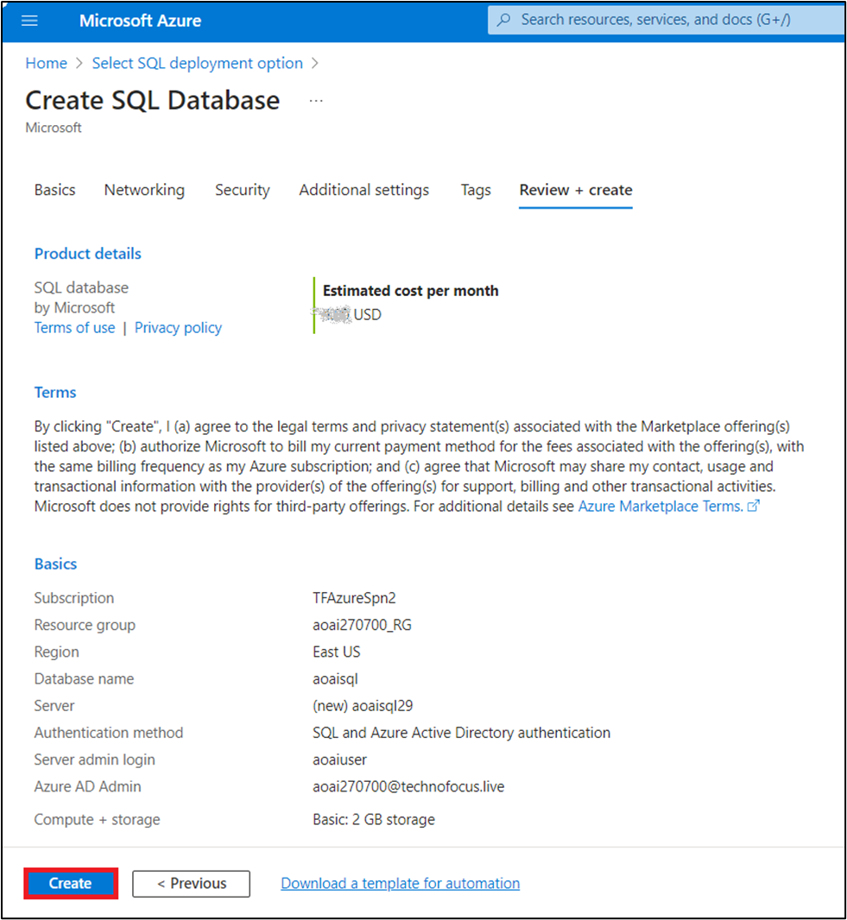

1. The Deployment would be completed in 3-5 minutes.

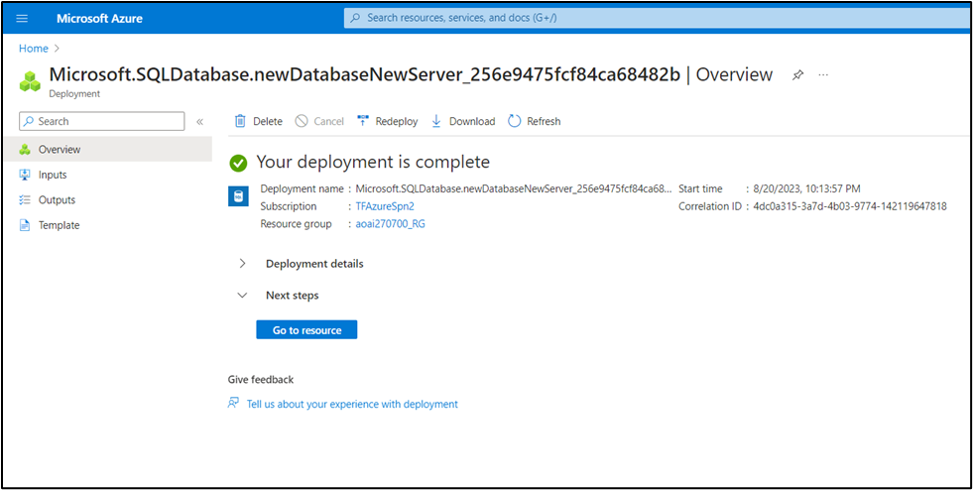

1. After the deployment is completed, click on the **Go to resource** button.

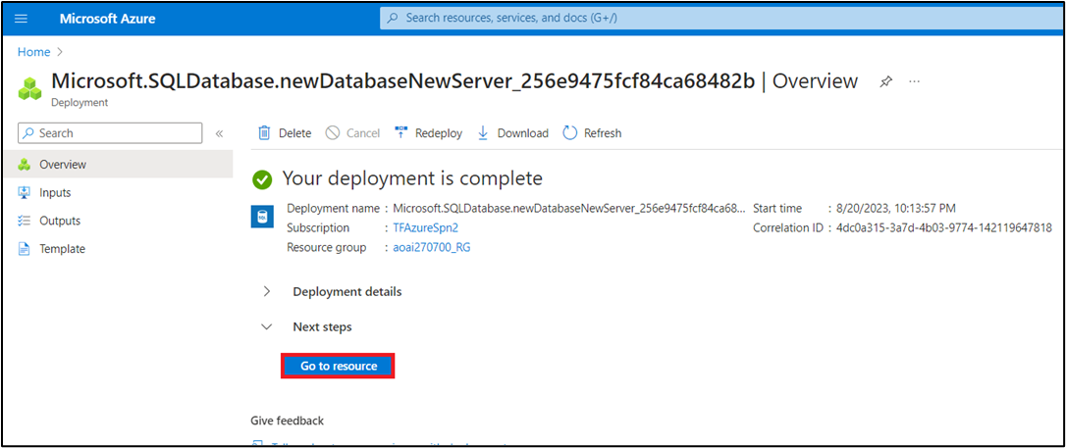

1. In **aoaisql (aoaisql29/aoaisql)** page, copy **SQL database** and **Server name** and paste them on a notepad (as shown in the below image), and then **Save** the notepad to use the information in the upcoming lab.

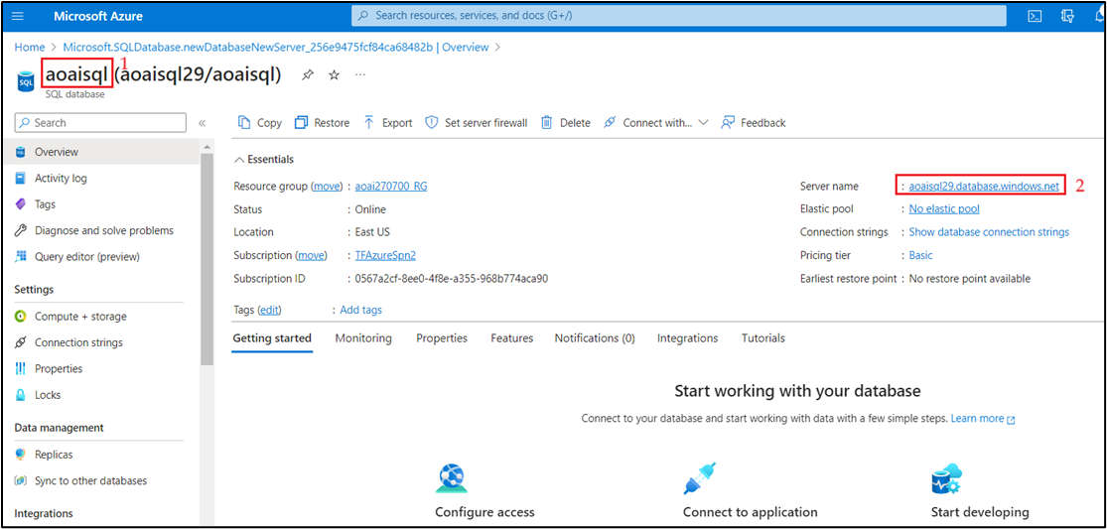

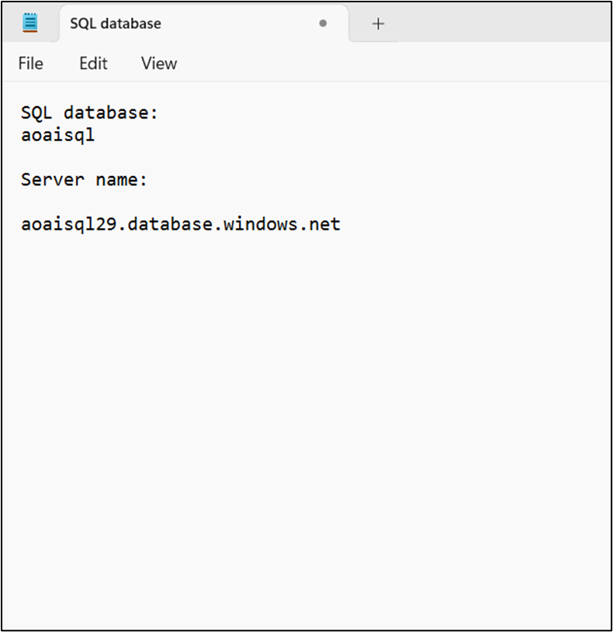

**Task 4: Configure and use the demo application for SQL query translation and advanced data analysis**

1. Open your browser, navigate to the address bar, and type or paste the following URL: **https://app-web-ulajovkr7vyd4.azurewebsites.net/>** then press the **Enter** button.

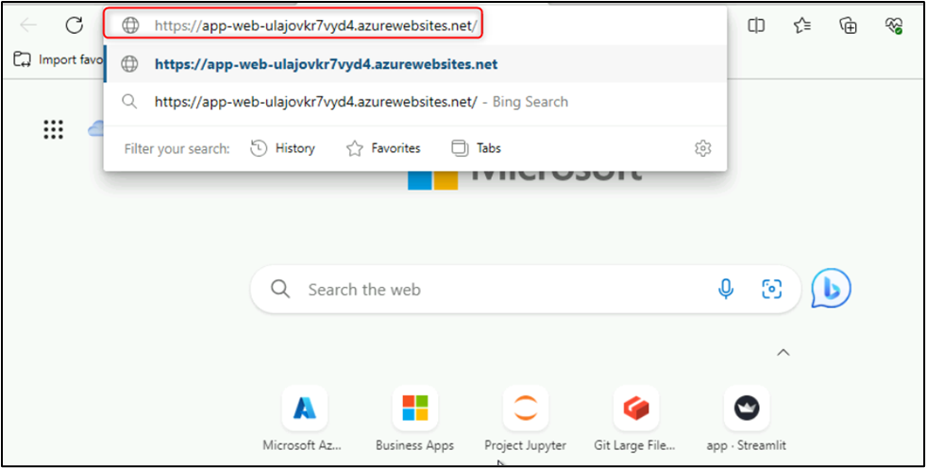

1. On the **web app** page, in the left side navigation menu, click on **Settings** button.

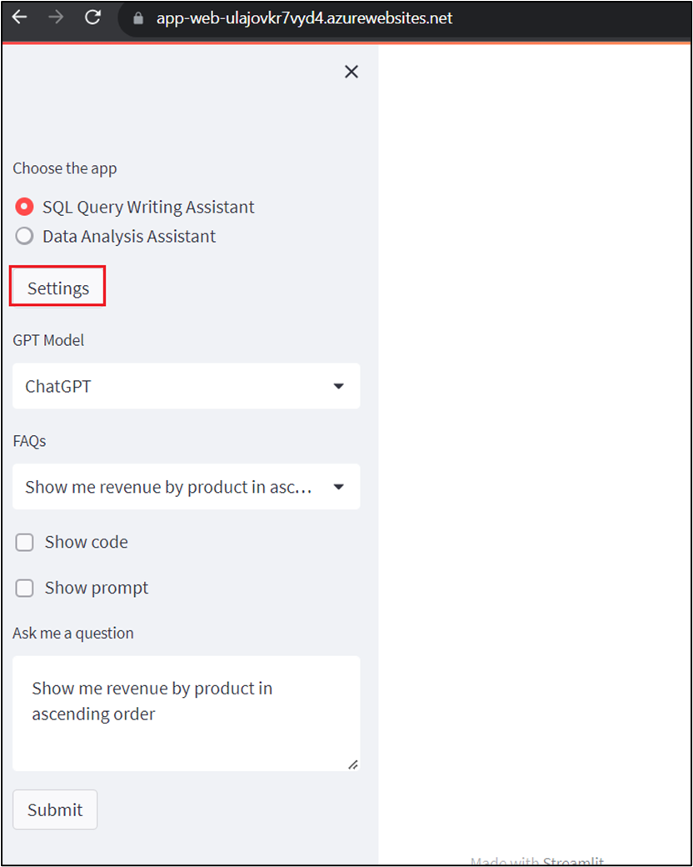

1. Under **Azure OpenAI Settings**, enter the below details and then click on the **Submit** button.

| **Property** | **Value** |
| --- | --- |
| ChatGPT deployment name | **gpt-35-turbo** |
| GPT-4 deployment name (if not specified, default to ChatGPT's) | **gpt-4** |
| Azure OpenAI Endpoint: | Enter Azure OpenAI Service Endpoint (Endpoint information that you have saved on your notepad in **Lab #1)** |
| Azure OpenAI Key | Enter Azure OpenAI Key (Key information that you have saved on your notepad in **Lab #1)** |
| SQL Server | **aoaisqlXX.database.windows.net** (SQLServer *information that you have saved on your notepad in****Task 1****of this lab)* |
| Database | **aoaisql** (Database information that you have saved on your notepad in **Task 1** of this lab) |
| User | **aoaiuser** |
| Password | **Password321!** |

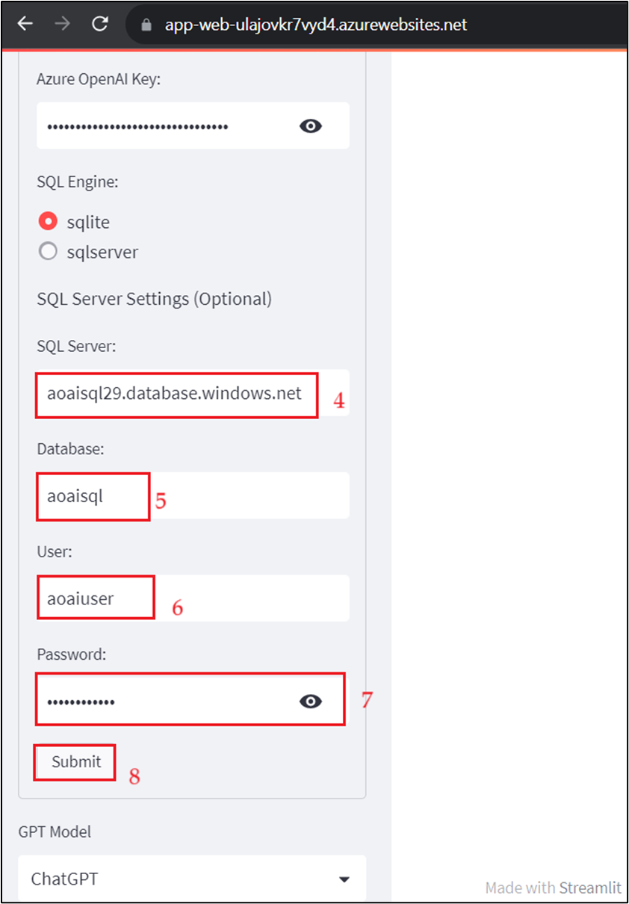

1. There are two applications
   * SQL Query Writing Assistant: A simple application that translate business question into SQL query language, then execute and display result.
   * Data Analysis Assistant: A more sophisticated application to perform advanced data analytics such as statistical analysis and forecasting. Here, we demonstrate the use of [Chain of Thought](https://arxiv.org/abs/2201.11903) and [React](https://arxiv.org/abs/2210.03629) techniques to perform multi-step processing where the next step in the chain also depends on the observation/result from the previous step.
2. Use SQL Query Writing Assistant in the web app page - Under **Choose the app**, select **SQL Query Writing Assistant** radio button, select **GPT Model** as **ChatGPT** then select **Show code** box. Under **Ask me a question** text box, enter the following question and click on the **Submit** button.

**Show me revenue by product in ascending order**

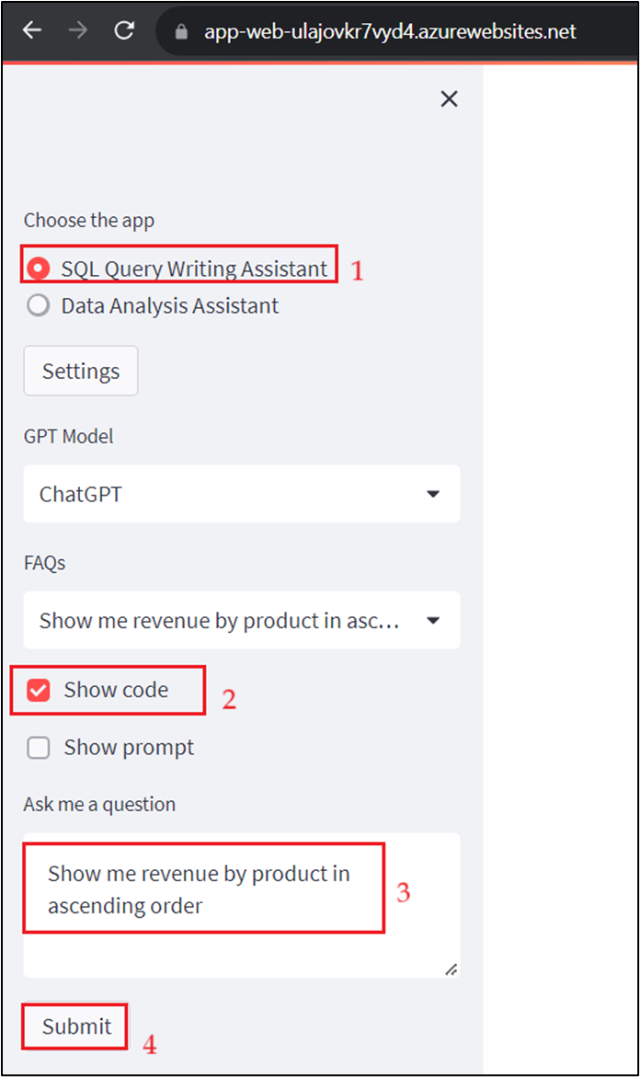

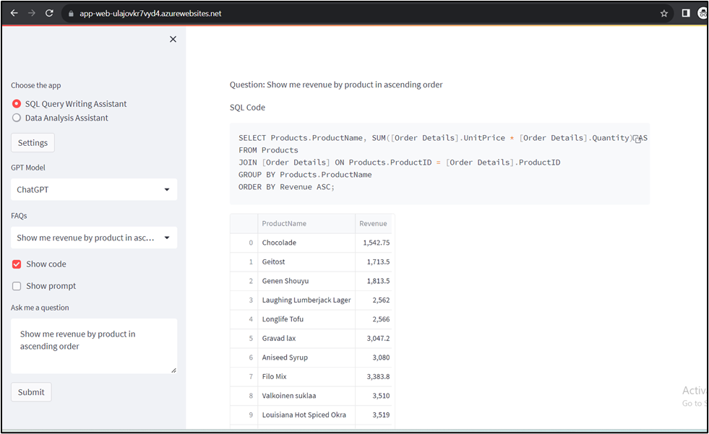

1. Use SQL Query Writing Assistant in the web app page - Under **Choose the app**, select **SQL Query Writing Assistant** radio button, select **GPT Model** as **GPT 4** then select **Show code** box. Under **Ask me a question** text box, enter the following question and click on the **Submit** button.

Pick top 20 customers generated most revenue in 2016 and for each customer show 3 products that they purchased most

1. Now, use Data Analyst Assistant in the web app page - Under **Choose the app**, select **Data Analysis Assistant** radio button, select **GPT Model** as **GPT 4** then select **Show code** box and **Show prompt**. Under **Ask me a question** text box, enter the following question and click on the **Submit** button. \

Pick top 20 customers generated most revenue in 2016 and for each customer show 3 products that they purchased most

1. Now, use Data Analyst Assistant in the web app page - Under **Choose the app,** select **Data Analysis Assistant** radio button, select **GPT Model** as **Chat GPT** then select **Show code** box. Under **Ask me a question** text box, enter the following question and click on the **Submit** button.

**Show me daily revenue trends 2016 per region**

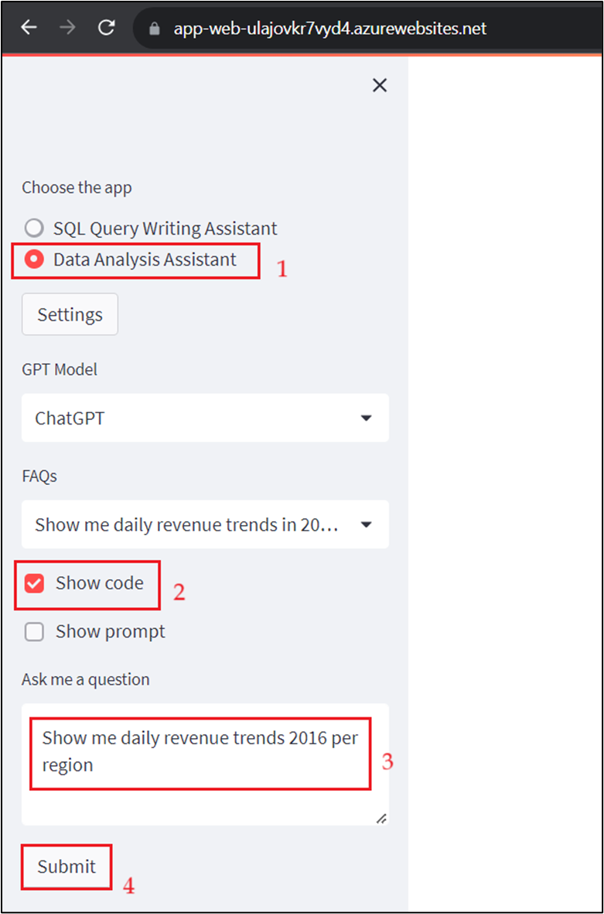

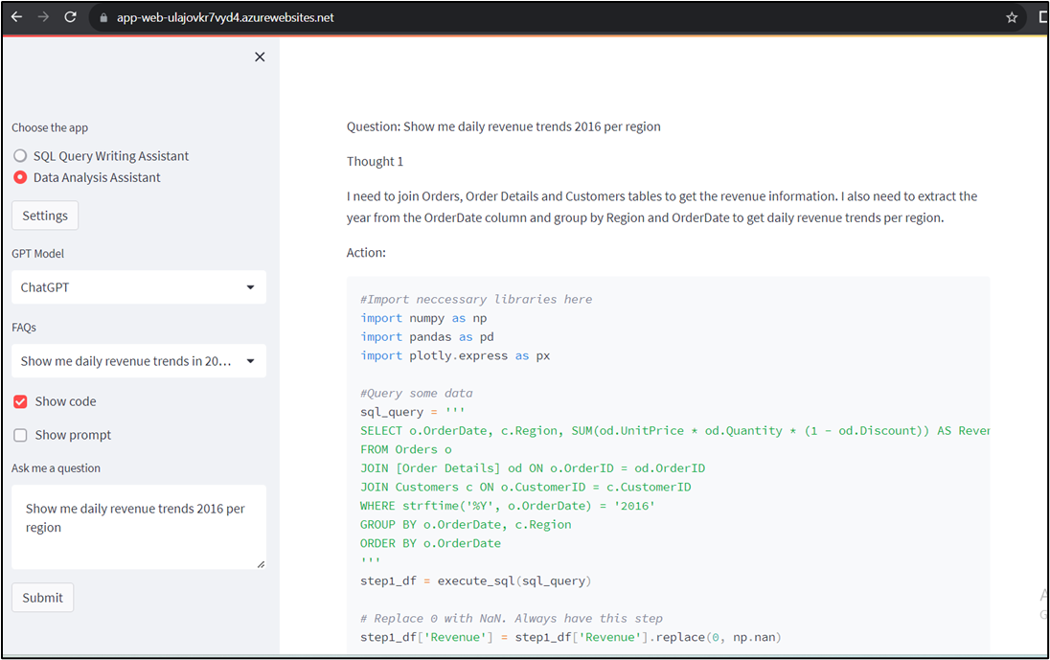

1. For advanced questions such as forecasting in the web app page, under **Choose the app,** select **Data Analysis Assistant** radio button, under **Ask me a question** text box, enter the following question and click on the **Submit** button.

**Note**: This time do not select **Show code** box.

**Predict monthly revenue for next 6 months starting from June 2018. Do not use Prophet.**

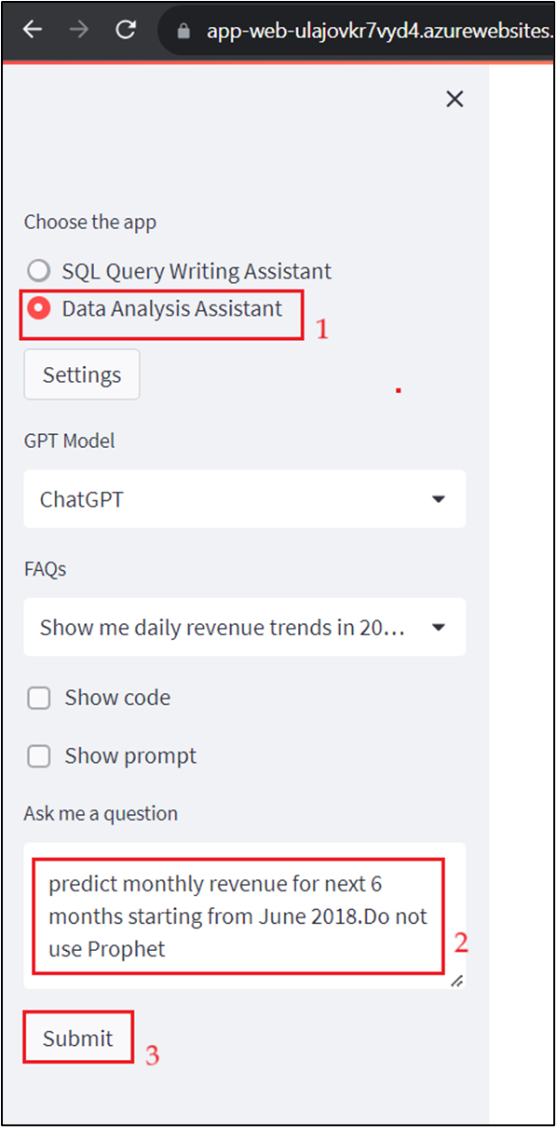

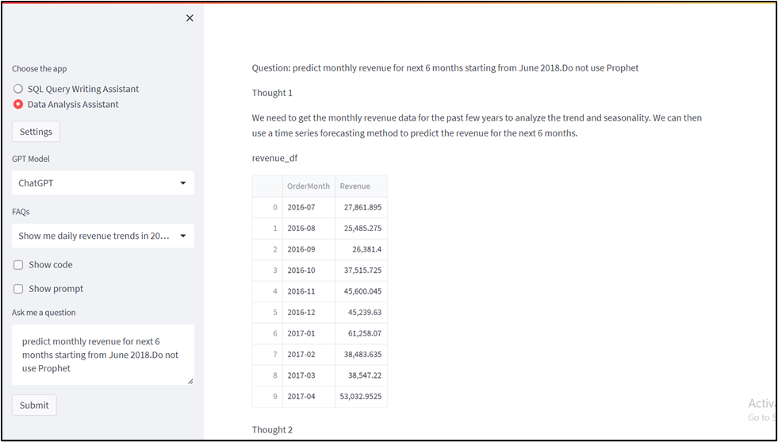

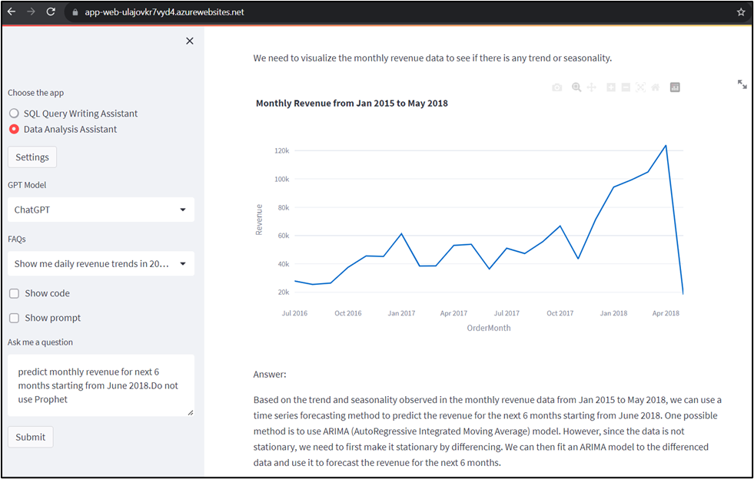

**Task 4: Delete the deployed model**

1. In Azure OpenAI Studio, on the left pane, under the **Management** section, click on **Deployments**.

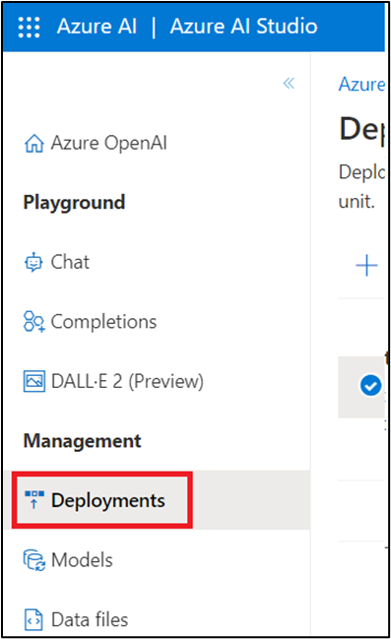

1. Select **gpt-35-turbo** deployment name and click on **Delete deployment**.

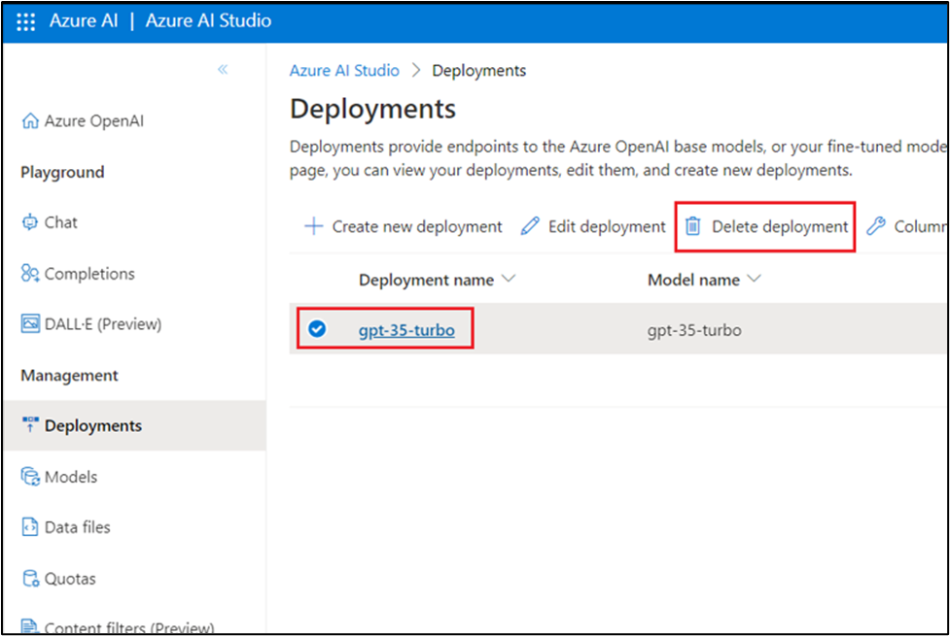

1. In the **Confirm delete** dialog box, click on the **Delete** button. You will see the notification -- **Successfully Deleted deployment**.

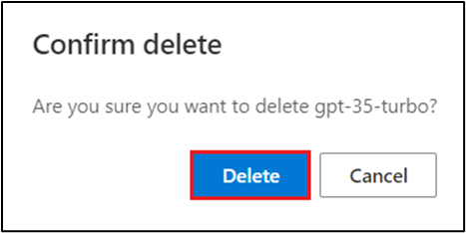

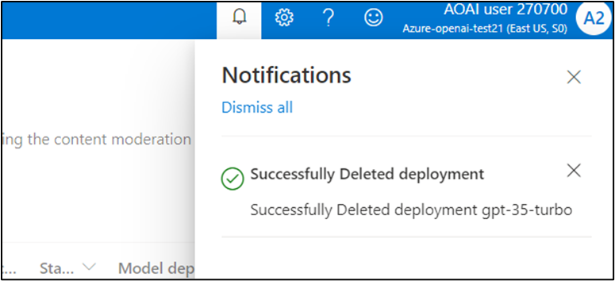

1. In Azure OpenAI Studio, on the left pane, under the **Management** section, click on **Deployments**.

1. Select **gpt-4** deployment name and click on **Delete deployment**.

1. In the **Confirm delete** dialog box, click on the **Delete** button. You will see the notification – **Successfully Deleted deployment.**

**Task 5: Delete the SQL database and SQL server**

1. To delete the SQL database and server, navigate to **Azure portal Home** page, click on **Resource groups**.

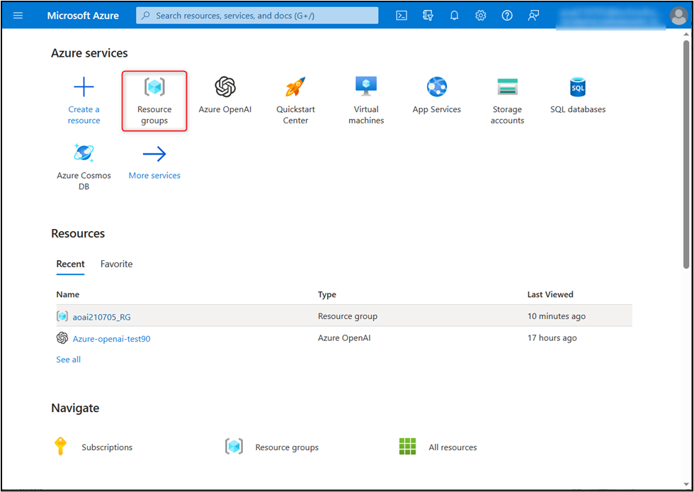

1. Click on the assigned resource group.

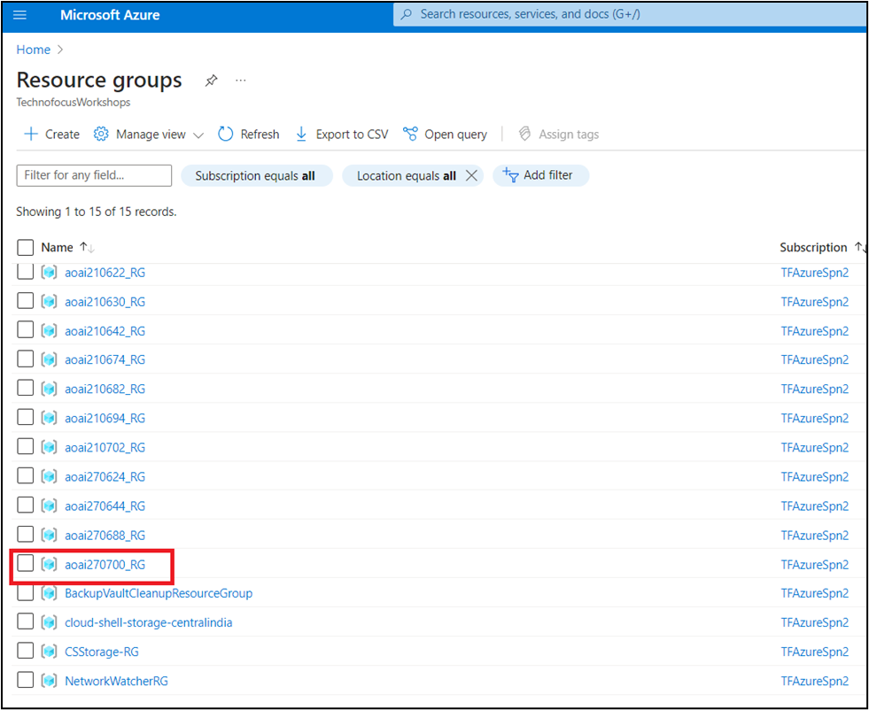

1. Select SQL database and SQL server that you've created.

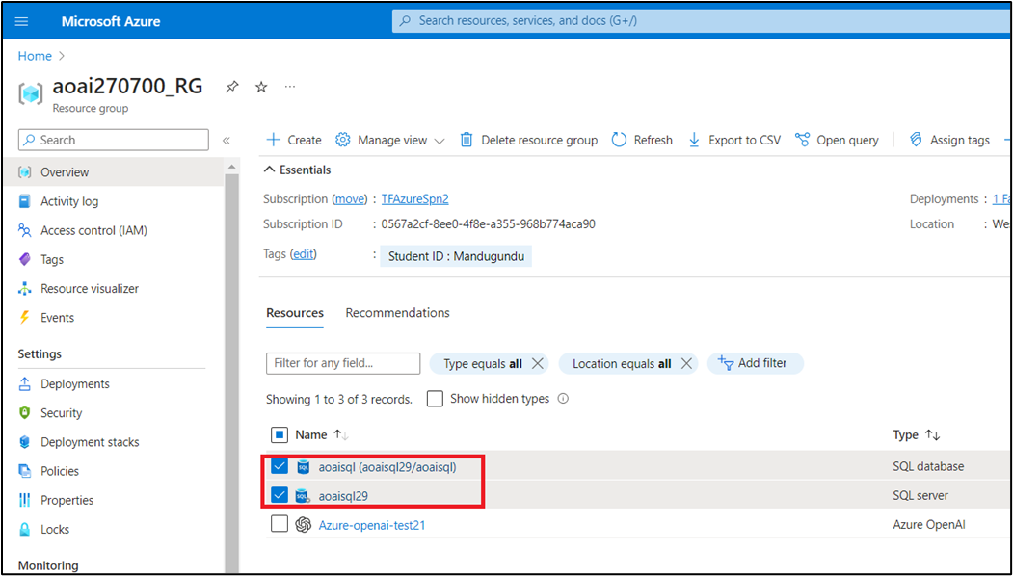

1. In the Resource group page, navigate to command bar and click on **Delete**.

**Note**: In case, you did not see the **Delete** option on the command bar, then click on the horizontal ellipsis, navigate and click on **delete**.

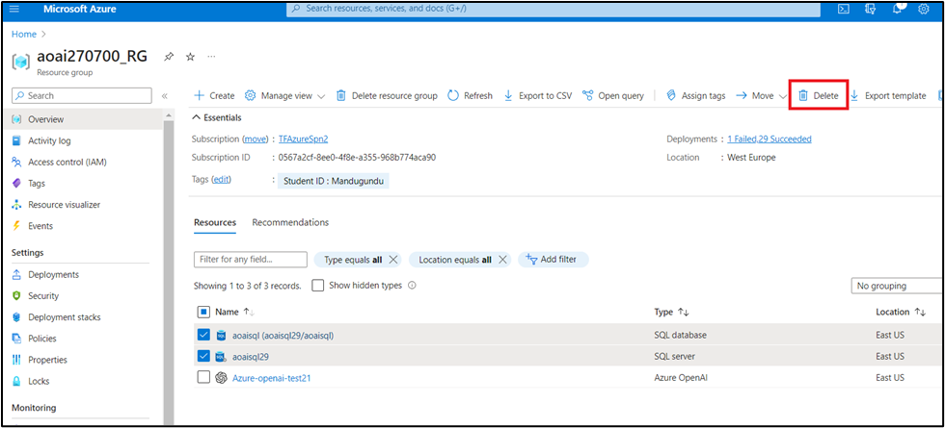

1. In the **Delete Resources** pane that appears on the right side, enter **delete** and then click on **Delete** button.

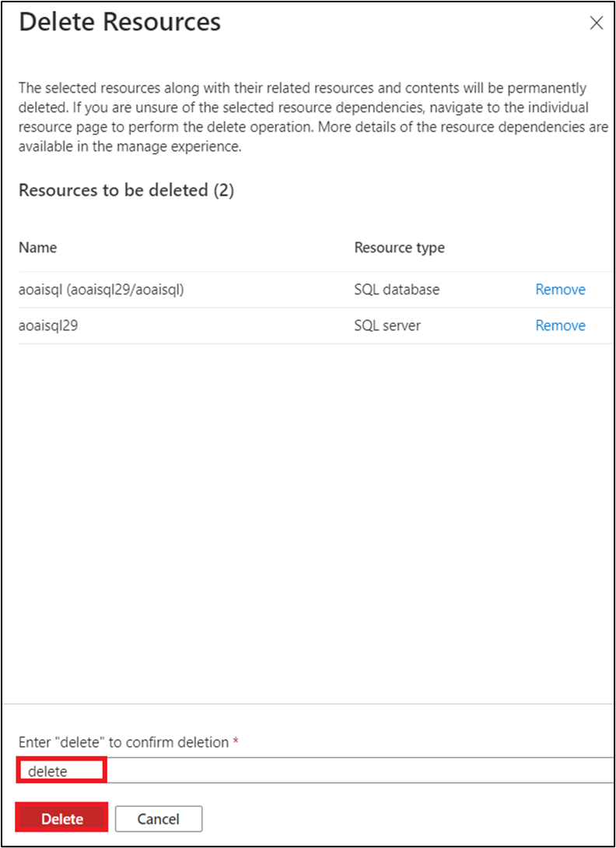

1. On **Delete confirmation** dialog box, click on the **Delete** button.

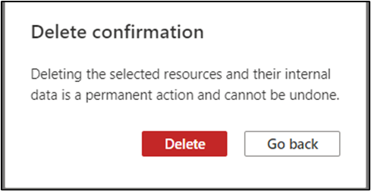

1. Click on the bell icon, you'll see the notification -- **Executed delete command on 2 selected items**.

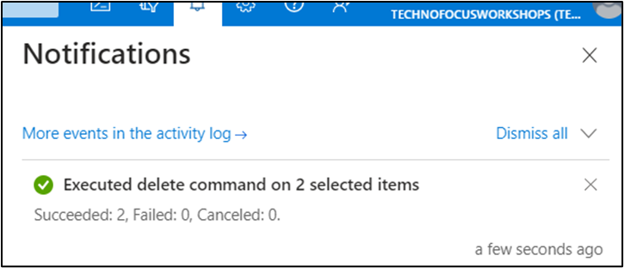

**Summary**

In this lab, you've deployed gpt-35-turbo model in Azure AI Studio and created

an Azure SQL Database with relevant configurations. Then, you've configured the hosted demo application. You\'ve used SQL Query Writing Assistant of the demo app to translate business question into SQL query language, then executed it and viewed the result. Then, you\'ve used Data Analysis Assistant of the hosted demo app to perform advanced data analytics. You\'ve deleted the gpt-3-turbo model, SQL database, and SQL server to effectively and efficiently manage the Azure OpenAI resources.

**Important Note: Please do not delete the Resource group and Azure OpenAI Service (Azure-openai-testXX). The same Resource group and AOAI service will be used throughout all the labs.**